README FILE FOR

ARMENIA 2008

Date: April 2024
Author: Pierre Walthéry, CTUR UCL

1. TECHNICAL DESCRIPTION OF THE SURVEY

Geographical coverage | Republic of Armenia | Secondary activity column | Yes
Survey period | 01-10 and 31-10 2008 | Location column | Yes, but limited
Age range | 15+ | Mode of transport column | Yes
Multi-member household survey | YES | Who else was present column | Yes, but limited
N. of diaries per person | 2 | ICT column | No
Type of days | 1 weekday and 1 weekend per respondent. | Other columns | No
Diary start time | 1 am | Response rate | 50.7%, 499/984 contacted households
Duration of diary | 24 hours | N. of diaries (from adults and children)* | 2,680 (2514 adults and 166 children)
Time interval | 10 minutes | Low quality diaries | 1 diaries (0.04% of total)
Mode of data collection | NA (most likely paper). | N. of individuals | 1342
Who completes diary | No info is given but it is safe to assume that it is completed by the respondent. | N. of households | 499
Moment of data collection | Now and then during the observation day (N=41), at the end of the observation day (N= 2555), the day after the observation day (N=84). | Other comments | The sampling design- two stage random household survey. Sampling frame: households that took part to the 2001 Population Census, grouped by settlements, stratified by population density and region.

2. THE ORIGINAL FILES

Data source: The survey was carried out by the Armenian Statistics Office, in collaboration with Statistics Sweden.
When data was obtained: 2008 approx.
(1) File N. | (2) File name and extension | (3) File description
1 | diary.Ar.dta | Diary files, 10 min time slots
2 | episode.Ar.dta | diary-level information
3 | hh_Ar.dta | Household related info
4 | mem_Ar.dta | Individual info

3. THE DIARY INSTRUMENT

Original categories in diary instrument.
MAIN ACTIVITY | SECONDARY ACTIVITY | LOCATION
HETUS-based,108 distinct activity codes | Same as MAIN. | Unspecified location  Home  Second home  Workplace or school  Other people’s home  Restaurant, café or pub  Other specified location
MODE OF TRANSPORT | COPRESENCE | USE OF ICT DURING ACT.
Unspecified private transport mode  Travel on foot (Also waiting)  Travel by bicycle  Travel by moped, motorcycle or moto  Travel by passenger car  Travel by lorry, van etc.  Other specified private traveling  Unspecified public transport  Travel by taxi  Travel by bus or coach  Travel by underground | Children up to 9 living in  Other household members  Other persons that you know | NA

Difficulties while creating episode variables: None.

4. VALUE LABELS OF NON-HARMONISED VARIABLES

Value labels for ETHNIC

NA

Value labels for EDUCA

[1] illiterate

[2] incomplete primary

[3] primary

[4] general basic

[5] secondary

[6] preliminary vocational

[7] vocational

[8] incomplete tertiary

[9] tertiary

[10] post-graduate

Value labels for OCCUP

NA

Value labels for REGION

1 Yerevan

2 Aragatsotn

3 Ararat

4 Armavir

5 Gegharkunik

6 Lori

7 Kotayk

8 Shirak

9 Sjunik

10 Vayots Dzor

11 Tavush

5. IMPUTATIONS

We have not performed any automatic imputations for the time being since the program imputations.ado has some big that needs fixing. We may run this program in the future.

MAIN | SEC | MTRAV
None | None | None
ELOC | INOUT | WWALONE
None | None | None
WWCHILD | WWPARTNER | WWOTHERHH
None | None | None
WWNONHH | ICT
None | None

6. MISSING VALUES

Variables that should have few missing values (key background variables) | Episode variables
All of them have 0% missing values | main, 0  sec, 0  core, 0  mtrav, 0  eloc, 0  inout, 0  alone, 0  child, 0  sppart, 100  oad, 100  ict, 100
Vars that cannot be obtained (100% missing) | Background vars with more than 10% missing
av, sppart, oad, ict, cohab, empstat, workhrs, isco1, sector, empinclm, migrantd, citizen, rushed, carer, empsp, vehicle, internet | None.

7. QUALITY CHECKS

Comparing the survey with a specific survey
Survey used for comparison: | UK 2014

Change in main 4 categories (in minutes):
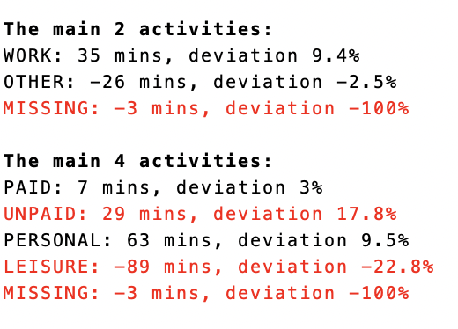 | 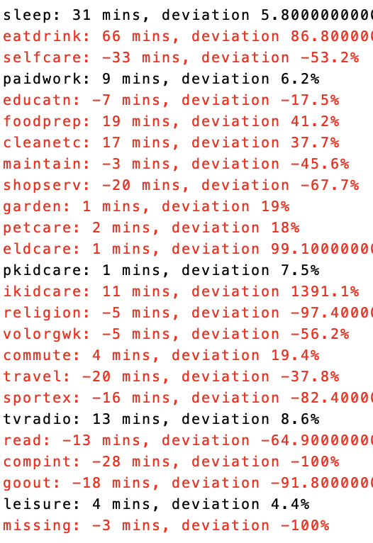

Comparing with MTUS averages*

Deviation from the MTUS-average in main 4 categories (in minutes):
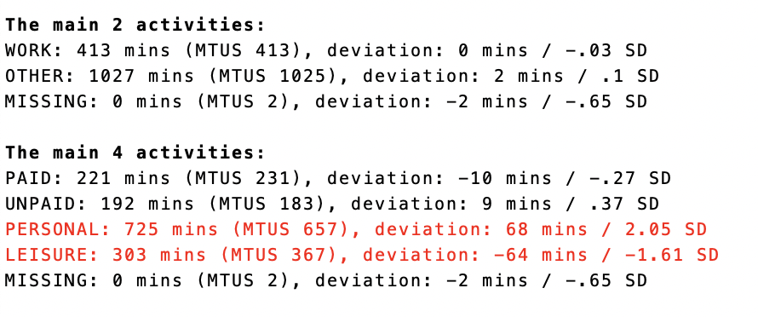 | 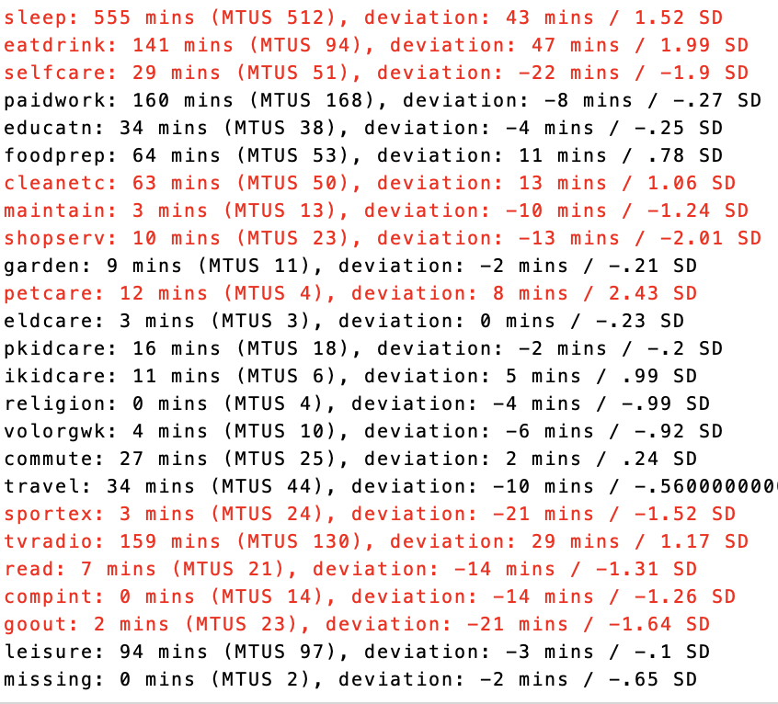

8. ABOUT WEIGHTS

The sampling procedure and the weights created are described clearly and with great detail in the main report of the documentation (pages 111 to 113). The dataset comes with two weights: hhwgtadj and perwgt, the first is a household weight and the second a person weight, but since there is one diary per person, this weight is also the diary level weight we are looking for. perwgt is OCOMBWT, from which we create PROPWT.

9. DIFFERENCES WITH PREVIOUS VERSION

There is no previous version to compare with.

10. ADDITIONAL COMMENTS AND APPENDICES

There is no occupation variable available in the original dataset. Variable A7 records ‘The type of activity connected with your job or own business´, which could be either, and unfortunately is not labelled.

11. CORRESPONDENCE BETWEEN THE ORIGINAL ACTIVITY VARIABLE AND MAIN

* MAIN 1: Sleep
11 Sleep/in bed
12 Sick in bed

* MAIN 2: Eat and drink at home
21 Eating

* MAIN 3: Eat and drink at the workplace
No activities in this category

* MAIN 4: Eat and drink at a restaurant
No activities in this category

* MAIN 5: Wash, dress, care for self
30 Unspecified personal care
31 self-care
39 Other self care

* MAIN 6: Personal care services
363 Personal services (visiting a doctor, barber)

* MAIN 7: Paid work at the workplace
100 Unspecified employment
111 Working in main job
121 Working in second job
130 Unspecified activities related to employment
139 Other activities related to employment

* MAIN 8: Paid work at home
No activities in this category

* MAIN 9: Travel as part of paid work
No activities in this category

* MAIN 10: Work breaks
112 Coffee and other breaks in main job
122 Coffee and other breaks in second job
131 Lunch break

* MAIN 11: Look for work
No activities in this category

* MAIN 12: Unpaid work to generate household income
No activities in this category

* MAIN 13: Regular schooling and education
200 Unspecified study
210 Unspecified activities related to school /uni
211 Classes and lectures
219 Other activities related to school/uni

* MAIN 14: Homework
212 Homework

* MAIN 15: Other education and training
221 Free time study

* MAIN 16: Cleaning and tidying up
300 Unspecified hh and family care
320 Unspecified household upkeep
321 Cleaning dwelling
322 Cleaning yard
323 Heating and water supplying for hh
324 Various arrangements
325 washing carpets
329 Other household upkeep

* MAIN 17: Food preparation and cooking
310 Unspecified food management
311 Food preparation
312 Baking
314 Preserving
319 Other food management

* MAIN 18: Wash and put away dishes
313 Dish washing

* MAIN 19: Laundry and other textile care
326 washing wool for blanket
330 Unspecified making/care for textiles
331 Laundry
332 Ironing
339 Other specified making and care for textiles

* MAIN 20: Home and vehicle maintenance
350 Unspecified construction and repairs
351 House construction and renovation
352 Repairs of dwelling
353 Making, repairing, maintaining equipment not for sale
354 Vehicle maintenance
359 Other specified construction and repairs

* MAIN 21: Gardening and productive exercise
341 Gardening, vegetables, harvesting, not for sale
349 Other specified gardening and pet care
620 Unspecified productive exercise (fishing,picking berries)

* MAIN 22: Household management
371 Household management

* MAIN 23: Shopping
360 Unspecified shopping and services
361 Shopping
369 Other specified shopping and services

* MAIN 24: Commercial and administrative services
362 Commercial and administrative services

* MAIN 25: Physical and medical childcare
380 Unspecified childcare
381 Physical child care and supervision
389 Other specified childcare

* MAIN 26: Teach and help with homework
382 Teaching the child

* MAIN 27: Read to, talk or play with children
383 Reading, playing and talking with child

* MAIN 28: Supervise, accompany children
384 Accompanying child

* MAIN 29: Adult care
391 Help to an elderly family member

* MAIN 30: Pet care
342 Tending domestic animals not for sale
343 Caring for pets
344 Walking the dog

* MAIN 31: Attend sporting event
No activities in this category

* MAIN 32: Cinema, theatre, opera, etc.
520 Entertainment and culture(cinema,library, sports events)

* MAIN 33: Walking and hiking
No activities in this category

* MAIN 34: Cycling
No activities in this category

* MAIN 35: Other sports or exercise
600 Unspecified sports and outdoor activities
610 Physical exercise
611 Physical exercise

* MAIN 36: Watch TV, streamed content, DVD
820 TV and video

* MAIN 37: Listen to radio, music and other
830 Radio and music

* MAIN 38: Read
810 Unspecified reading
811 Reading periodicals
812 Reading books
819 Other specified reading

* MAIN 39: Socialising with the family
500 Unspecified social life and entertainment
510 Social life (communication with family, phone etc)
511 conversation with family members

* MAIN 40: Receive or visit friends
512 conversation with neighbors

* MAIN 41: Audio and video conversation
No activities in this category

* MAIN 42: Written communication (emails, texts)
No activities in this category

* MAIN 43: Celebrations
No activities in this category

* MAIN 44: Voluntary work
420 Unspecified informal help
421 Food management as help
422 Household upkeep as help
423 Gardening and pet care as help
424 Construction and repairs as help
425 Shopping and services as help
426 Help in employment and farming (unpaid)
427 Childcare as help
428 Help to an elderly of another household
429 Other specified informal help
431 Meeting
439 Other specified participatory activities
995 Filling in the time use diary

* MAIN 45: Religion
432 Religious activities

* MAIN 46: Arts and crafts
333 Handicraft and producing textiles
710 Arts (painting,photography,playing,singing)

* MAIN 47: Hobbies
700 Unspecified hobbies and games
720 Hobbies (collecting things, writing, reading)

* MAIN 48: Games and play
730 Games
731 playing national game nardi

* MAIN 49: Computer games
No activities in this category

* MAIN 50: Surf internet, computing
No activities in this category

* MAIN 51: Resting, time out
530 Resting- time out

* MAIN 52: Travel to/from work
913 Travel to/from work

* MAIN 53: Travel related to education
921 Travel to/from school or university
922 Travel related to free time study

* MAIN 54: Travel related to childcare
938 Transporting a child and an elderly family member

* MAIN 55: Travel related to other unpaid work
931 Travel related to household care
936 Travel related to shopping and services

* MAIN 56: Travel related to voluntary work and religion
943 Travel related to social life, entertainment etc

* MAIN 57: Other travel
900 Unspecified travel purpose
901 Travel related to personal care

* MAIN 58: Missing time
No activities in this category

